Progress Update
Local Resident FAQ’s
January 2021

Clear Communication
Local Resident Q&A
Progress Update

Progress Update

New Granville and Mulalley would like to keep you up to date with what’s currently happening on site and what to expect over the next 6 to 12 months…
Total Programme dates:
- Completion of the regeneration project is currently estimated for October 2023 taking into consideration recent delays on site as a result of Covid-19.
Beech Court Site (Block A):
- Fourth floor concrete frame slab is complete and walls & columns to the roof have commenced.
Substation, Pump Houses & Pram Sheds:

- The substation near Granville Point has a temporary concrete slab & hardstanding installed to enable the statutory body to install the transformer.
- The Harpenmead substation brickwork is completing to roof level.
- The Templewood substation foundations & retaining walls are complete and the ground floor slab has commenced.

Houses on the Corner of Nant Road:

- The second floor is complete, and brickwork and blockwork continue to roof level.

Block of flats added to the end of Nant Court (Block B):

- The drainage and foundations are complete, and we are forming the ground floor concrete slab.

Infrastructure, Roads and Services:

- Roads and draining works are ongoing across the site.
- Gas service diversions at the front of Nant Court are due to commence end of January 21

Temporary Car Park (Block C):

- The temporary car park is in place for Granville Estate Residents use and has had a height restrictor installed to deter fly tipping.

Please see some progress photos below…more are available on our website at www.newgranville.co.uk
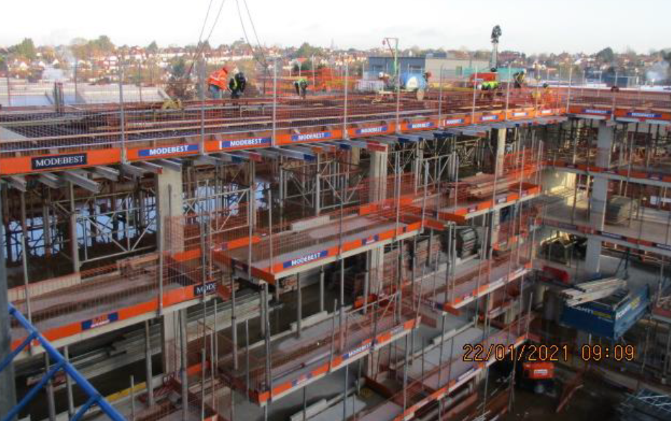
Beech Court Site and houses on the corner of Nant Road

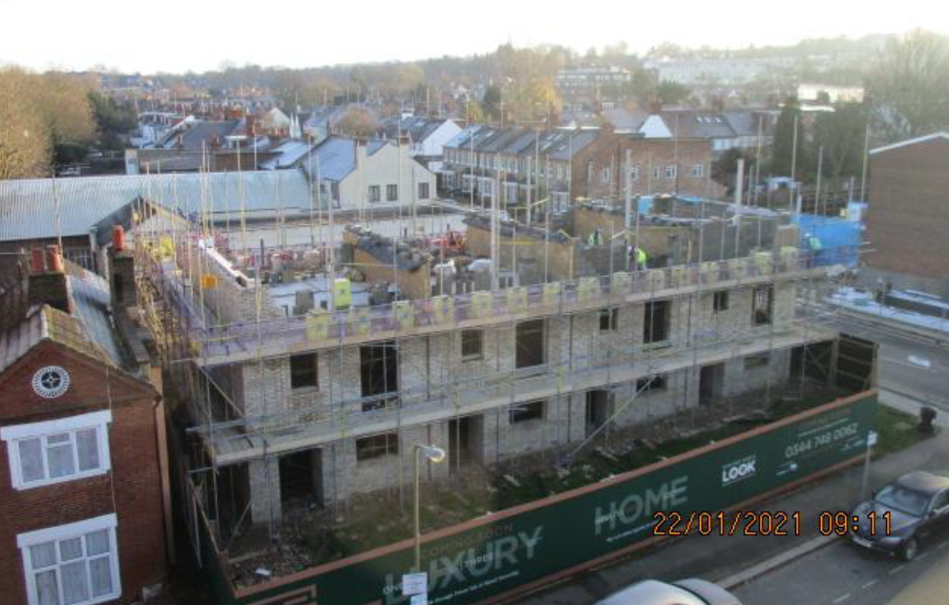

Flats added to Nant Court (Block B) and Harpenmead Substation

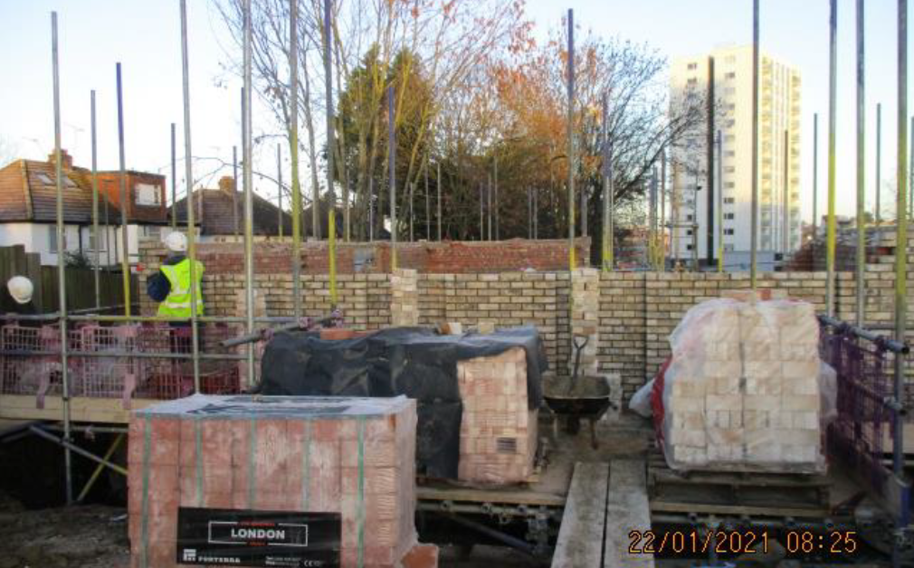
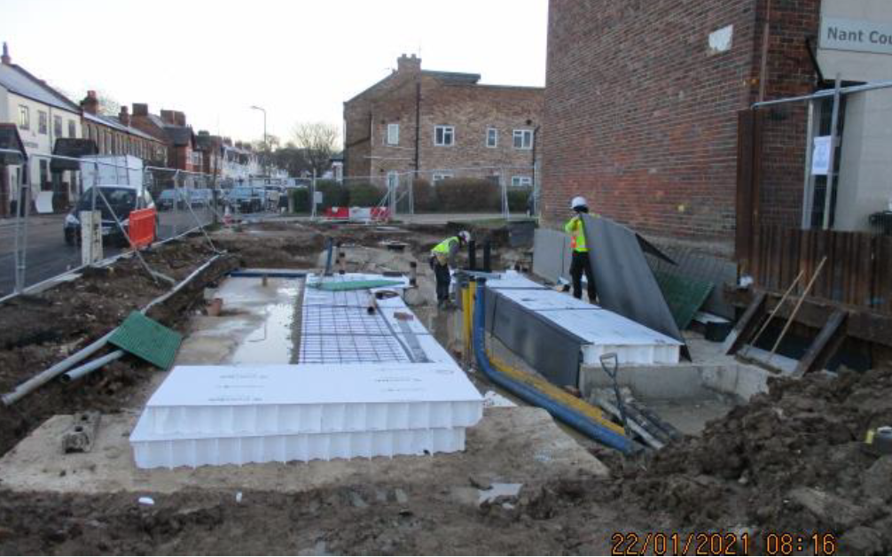
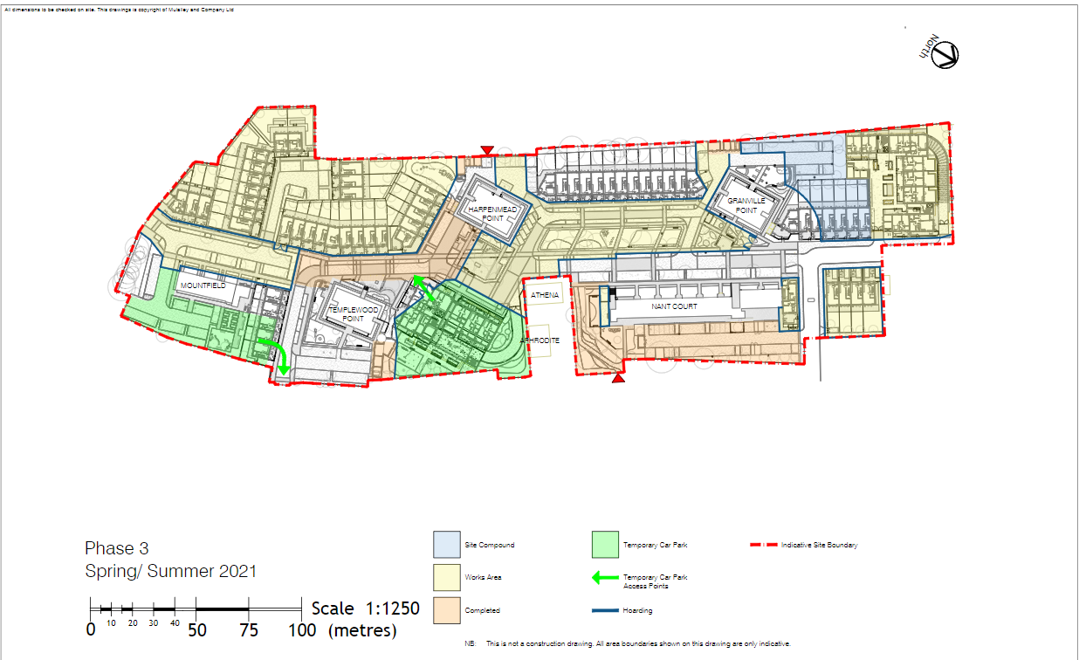
Works scheduled for Summer/Autumn 2021
Upcoming Works…Construction Programme Drawing

Local Resident ‘Questions and Answers’

The FAQ’s below are to help provide you with some information about key issues related to how the building works impact local residents...
Q. How is construction traffic managed?
A. Before works start on site a Construction Management and Logistics plan is submitted for approval by the Local Planning Authority. This has detailed information about things like traffic, noise and how waste is managed on site to name a few.
At New Granville we have Traffic Marshals, Banksman and Gatemen on site. They direct traffic to ensure the movement of vehicles is conducted safely. There are several approved routes for construction traffic to arrive and depart the site and these are identified in the Construction Management Plan. The main routes utilize the larger roads such as Finchley Road, Hendon Way and Cricklewood Lane. The Traffic Marshals are on hand to ensure the best route is chosen. Recently they have been turning vehicles around to exit they way they arrived to help ease congestion on Crewys Road at peak hours.
Please visit our website for a Copy of the planning approved Construction Management and Logistics Plan at www.newgranville.co.uk
Q. Is construction traffic likely to arrive during peak ‘rush hour’ times of day?
A. No, we have used predicted traffic movements from TFL data to assess peak times for rush hours and the school run and scheduled deliveries to avoid these times. This is constantly monitored. Delivery’s also only have a 30 min window to arrive and a maximum of 3 deliveries will be held on site at any one time to avoid congestion.
Q. How many deliveries are expected on average during a typical day on site?
A. The number and types of deliveries depend on the activity on site. On most average days there would be approximately 5 lorries and 5 van deliveries. There will be exceptions when we are excavating & pouring foundations for areas such as the basements where there will be up to 20 additional lorries per day taking away the excavated soil. There are other commercial operations on Granville Road and other development sites that also add to construction traffic that New Granville are not responsible for.

Q. How do you manage the delivery of large machinery and vehicles?
A. Deliveries of major plant and equipment such as cranes and piling rigs is coordinated with the subcontractors. Sometimes this can lead to suspending parking bays to allow long vehicles to turn correctly. Similarly, it may be necessary to arrange these deliveries at night or the early hours of the morning to cause the least traffic disruption.
Q. Can I park my car on Granville Road Estate?
A. All Granville Road Estate residents can apply for permits to park any vehicles registered to their address free of charge.
If you are a resident of the surrounding area such as Nant Road, Crewys Road or Llanelly Road you will not be able to park on Granville Road Estate. The parking is for Granville Road Estate only. You are however able to apply for a permit from London Borough of Barnet to park in the CPZ areas at www.barnet.gov.uk/parking/parking-permits
Q. Why can’t I park on Granville Road Estate
A. The parking permit system has been introduced to secure parking for the Granville Road Estate residents. The parking is therefore for the exclusive use of these residents only.
Q. What area is covered by CPM’s parking permits and patrols.
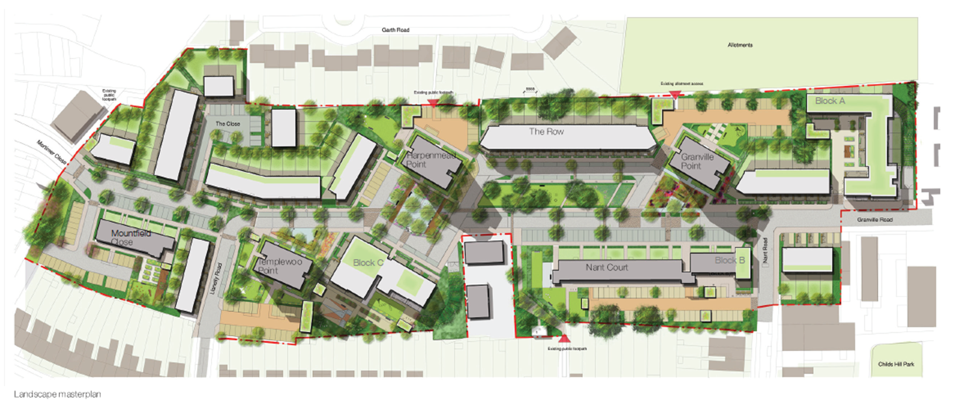
A. The below drawing shows the outline of the New Granville Estate regeneration. This is the area that will be redeveloped with new housing and landscaped public realm. The thin red line that surrounds this plan shows the area that parking is controlled by CPM’s permits and their patrol team.
Clear Communication
How to stay informed and who to contact…
If you have a question, then it’s important to know who to ask because there are different companies and people involved in the New Granville Regeneration.
Q. Who do I contact if I want to know more about the New Granville Road regeneration or I have a problem related to the construction works?
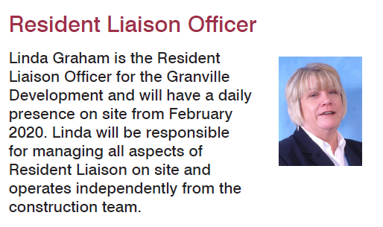
A. New Granville have set up a number of ways of keeping you informed of our progress. Information is online at our website, via a newsletter and on notice boards on the hoarding. We also have a Resident Liaison Officer, Linda Graham to help you with your queries.
RLO.SWG194@mulalley.co.uk

New Granville will be posting the newlestter to all residents on the Granville Road Estate and residents of Crewys Road, Llanelly Road and Nant Road from March 2021.
Website: www.newgranville.co.uk
For more information contact | Linda Graham, Resident Liaison Officer (RLO)  EMAIL: RLO.SWG194@mulalley.co.uk

